Please print this form and mail with details and payment to
ABN: 22 989 261 435
TAX INVOICE

P.O. Box 1170, Cragieburn 3064
Phone: 0419 716 171
Email: office@parentsvictoria.asn.au

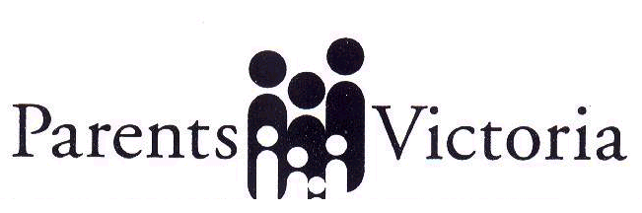
www.parentsvictoria.asn.au

Application for Individual Membership

Name ………………………………………………………………….........

Address ……………………………………………………………………..

………………………………………………………………………………

Phone ……………………. Email ……………………………………….

Schools your children attend:

………………………………………………………………………………

I wish to apply to become an individual member of Parents Victoria.
I agree to support the Statement of Purposes of Parents Victoria.
I am the parent/guardian of a child who attends a government school.
My child’s school either does not have a Parent Club or has chosen not
to affiliate with Parents Victoria.

Signed …………………………………….. Date …………………..

Membership fee is $50 (including GST) per calendar year.

